Project Design Phase-II
Data Flow Diagram & User Stories

Date | 01 October 2026
Team ID | SWTID-2026-7653
Project Name | Script-Controlled ACL – Restrict Record Access Based on Field Value
Maximum Marks | 4 Marks

Data Flow Diagrams:
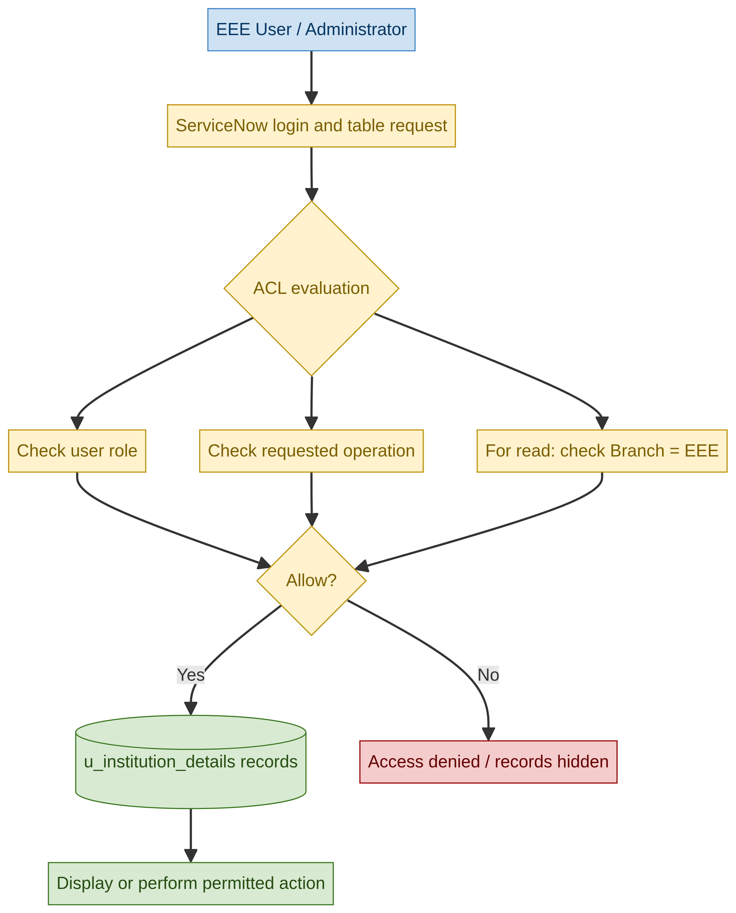
Project data flow: role, operation and Branch checks control access to u_institution_details.

User Stories
User Type | Functional Requirement (Epic) | User Story Number | User Story / Task | Acceptance criteria | Priority | Release
Administrator | User and role setup | USN-1 | As an administrator, I can create the EEE User and custom roles bb1, bb2, bb3 and bb4. | Users and roles exist and can be assigned. | High | Phase-2
Administrator | Table and data setup | USN-2 | As an administrator, I can create u_institution_details with the required student and Branch fields. | The table and fields are available. | High | Phase-2
EEE User | Read access | USN-3 | As an EEE User with bb1, I can view records where Branch is EEE. | EEE records are visible to the user. | High | Phase-2
Unauthorized user | Read access denial | USN-4 | As a user without the required role, I cannot view protected institution records. | Protected records are hidden or access is denied. | High | Phase-2
Administrator | Create access | USN-5 | As an authorized user with bb2, I can create an institution record. | The New action is available only when create access is granted. | High | Phase-2
Administrator | Write access | USN-6 | As an authorized user with bb3, I can edit permitted institution records. | Write access is available only when the write ACL permits it. | High | Phase-2
Administrator | Delete access | USN-7 | As an authorized user with bb4, I can delete permitted institution records. | Delete is available only when the delete ACL permits it. | High | Phase-2
Administrator | Verification | USN-8 | As an administrator, I can view all branches and verify ACL behavior by impersonating users. | Admin sees all records and test outcomes match the configured rules. | High | Phase-2

